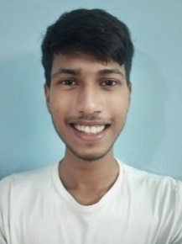 **Sachin Rajbhar**

**Mobile:** 8285895280

**Email Id:** officialsachinrajbhar@gmail.com

**Address:** RZ-S-43, Vishwas Park, UN, 110059

**Career Objective**

To obtain a part time Web dev. internship with Amazon Pvt. Ltd.

**Educational Qualification**

|  |  |  |  |
| --- | --- | --- | --- |
| **Qualification** | **From- To(Year)** | **Percentage** | **Institution** |
| BCA | 2021-2024 | **-** | DSEU Dwarka Sec-9 |
| 12th(C++)(PCM) | 2019-2020 | 81.2 | Jinvani Bharti Public School |
| 10th | 2017-2018 | 80.8 | Jinvani Bharti Public School |

**Additional Skills**

* YouTuber
* Public Speaking
* HTML, CSS
* MS OFFICE

**Industrial Internship**

My total experience is 1 month, the details of which are mentioned below:

|  |  |  |
| --- | --- | --- |
| **Company Name** | **From- To (Month/Year)** | **Position held** |
| Quick Pvt. Ltd. | Feb 2021- Mar 2021 | Sales (Part Time) |

**Awards & Certificates**

|  |  |
| --- | --- |
| **Year** | **Name** |
| 2019 | Tech Fest Award |
| 2018 | Gold Play Button |

**Portfolio (Project Work)**

Mini projects- Web and Android App development

I have taken some courses on Coursera and Udemy to learn the fundamentals

Fundamentals of Digital Marketing

I learned the principles of marketing digitally from Google Digital Unlocked

LinkedIn: [**https://www.linkedin.com/in/sachin-rajbhar-233868189**](https://www.linkedin.com/in/sachin-rajbhar-233868189)

**Personal Details**

DOB: 30-03-2002

Gender: Male

Languages Known: Hindi, Bhojpuri, English

**References**

Name: Mr. Love Babbar

Designation: SDE-1

Contact detail: [babbar@amazon.com](mailto:babbar@amazon.com)

**Declaration:** I hereby declare that the above information is true and best of my knowledge

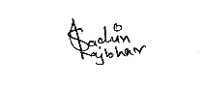Date: 29-12-2021 Signature